- API Example
Programmable Web, a site that tracks more than 15,500 APIs, lists Google Maps, Twitter, YouTube, Flickr and Amazon Product Advertising as some of the most popular APIs. The following list contains several examples of popular APIs:
1. Google Maps API: Google Maps APIs lets developers embed Google Maps on webpages using a JavaScript or Flash interface. The Google Maps API is designed to work on mobile devices and desktop browsers.
2. YouTube APIs: YouTube API: Google's APIs lets developers integrate YouTube videos and functionality into websites or applications. YouTube APIs include the YouTube Analytics API, YouTube Data API, YouTube Live Streaming API, YouTube Player APIs and others.
3. Flickr API: The Flickr API is used by developers to access the Flick photo sharing community data. The Flickr API consists of a set of callable methods, and some API endpoints.
4. Twitter APIs: Twitter offers two APIs. The REST API allows developers to access core Twitter data and the Search API provides methods for developers to interact with Twitter Search and trends data.
5. Amazon Product Advertising API: Amazon's Product Advertising API gives developers access to Amazon's product selection and discovery functionality to advertise Amazon products to monetize a website.
https://www.webopedia.com/TERM/A/API.html
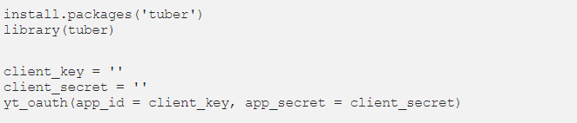
The tuber package for YouTube API
There is tuber package, which is made only for YouTube data analysis you can draw various data including the number of videos of a particular channel, the number of views, likes and comments on a video and so on.to call this data, you need to install “tuber” package first then you ask google for the authorization token.
When you comments this code, a browser will pop up with some numbers allowing you to authorize the application. If you check your local tool, get to be connected with YouTube API. Some of the functions that could be useful for analysing YouTube data from tuber package.
get_all_channel_video_stats: This is the function for getting statistics on all the videos in a channel. You need a channel_id to use this.
get_video_details: This provides more specific information as the publish date of a video. You can also get titles, descriptions, thumbnails, and categories.
get_all_comments: It gives you all the comments for a video so has great usage for text mining in respect of particular topics or channels
list_channel_activities: This returns a list of channel activity.
list_videos: It returns the most popular videos.
https://towardsdatascience.com/what-is-api-and-how-to-use-youtube-api-65525744f520

- How to evaluate AP

